2.2.4 Definition of user Specification – Centre line of an object (this application is mainly for longbones but can be used for other long objects)
ULB previously developed a method to analyse ribs using best fitting ellipses of external contours of the cross section areas, created from the centre line of the rib (Chapman et al., 2017). This method is of interest to palaeoanthropologists as they allow the quantification and analysis of bones in 3D space which are not possible through physical measurements (i.e. the method seeks to analyse the curvatures of the bone which is difficult to do in physical measurements).
The centre line was used to define a virtual osteometric box in Sookyoung (2017) and seems to be incredibly intuitive in MIMICS. Similar to the function previously developed at ULB in MATLAB, you can specify the distance between control points and take measurements along the centre line in MIMICS. You can also create best fit diameter, ellipses, sectional area. The centre line will also enable curvature to be analysed between bones and cross section ellipses to be created (similar to Chapman et al. (2017)
1) All results must be described and how these results should be presented. = OUTPUT data from new operations.

A menu with a checklist should open up on the screen and you can tick what you want from the results. These results can be in the form of an xls. File. The graph should be presented separately on the screen. If graphs are not possible then simply the raw data should be possible to be exported so it is possible to analyse length by curvature (for example). In addition to this, the possibility should be investigated to select a group of ribs and then ask the same questions of all the bones within the group and then export all data for the group. Visual pictures of the ellipses and axis orientations should be produced if possible. If you ask for chord length etc., then you should also be able to see this measurement on the rib (see Fig.1 below). Please note that the list is in order of priority!

- Total length (arc length) of an object from the far end points of the centre line (mm)
- Chord length (mm)
- Max Width (mm) (mean and standard deviation of all points)
- AP Bending (mm) (mean and standard deviation of all points)
- Twist angle (degree) (mean and standard deviation of all points)
- (Rib) curvature (degree) (mean and standard deviation of all points)
- Graph showing (Total length I. By Rib Curvature (VI) (See Fig.2 below)
- Graph showing (Total length I. By Twist angle.
- Curvature should be able to defined at a % point (i.e. it should be possible for the user to know what is the curvature at 10%.
- Area of cross section
- Area of cross section (end)
- Circumference of ellipses (mean and standard deviation of all points)
- Cross sectional ratio (mean and standard deviation of all points)
- Measures X,Y,Z from the bounding box (VRTX_X, Y and X)
- Area costo chondral end (taken from table of benoit)
- Circumference end (taken from table of benoit)
- Volume
- Total area
2) Methods and algorithms (with bibliographic references) to produce these results must be detailed.

Data requirements.
Bone data must be presented as closed triangulated surface (e.g. *.inp ASCII format) preferably without internal and/or external facets inclusion (e.g. as result of inaccurate 3D reconstruction). In case of pure raw (not cleaned) data for particular bone special cleaning procedure must be available (e.g. using another software).
Data processing.
GCS to LCS. Usually bone data are presented in Global CS (e.g. CT scan CS), so in order to unify data representation the bone data must be converted in Local CS, using some specified approach. The straightest one is based on 3 palpable and reproducible ALs (preferably, but not necessary, recommended by ISB). After data conversion in LCS user can select some method for final correction LCS on the bases of principal axis (PA) orientation and relative size (sorted eigen values), which could be also useful for the future data using in multibody system dynamics. PA evaluation can be implemented by using vertices only (with unit mass) or (more accurate) using each facet barycentre with weight factor proportional to facet area. Naming and orientation of the PA could be unified for each type of bone, for example suppose that longer PA oriented along X axis and the next one along Z axis (see Fig.1 below). After conversion in LCS bone data geometry could be preliminary classified (e.g. ‘longitudinal’ or ‘bended’) using banding box or PA relative size.
Virtual Rescanning. Longitudinal bones could be rescanned using parallel planes (e.g. perpendicular to long X axis). For each position of the plane the bone vertices data located in the predefined volume constrained by two close parallel planes could be selected. Then mean value of the selected data will define preliminary position of the current point on middle line. Following this procedure for a set of selections could be constructed the piecewise line and a new virtual rescanning could be applied by orienting parallel planes perpendicular to piecewise line with further correction of the midline.
Virtual rescanning of the bended bones is slightly different from longitudinal ones. First (preliminary) step use a plane rotated around selected point (e.g. obtained as a centre of the ellipse fitted from XZ bone vertices data projection). After application of two close parallel planes (as constraints) an additional constraint must be applied in order to escape inclusion of the extra vertices in case if the bone shape looks like almost close shape. Application of the spherical constraint surface with predefined radius located in the cloud points (obtained from parallel plane constraint) centre usually is good enough. Similar to longitudinal case final step is based on a new virtual rescanning by orienting parallel planes perpendicular to piecewise line and further midline correction.
Local cloud fitting. To analyse orientation of the vertices cloud shape selected in the previous step data must be converted in local cloud CS. There are suggested two options to construct LCS. First, cloud data could be projected on the plane perpendicular to midline and then fitted by ellipse. Fitting residual analyses by comparison with predefined one can be used to conclude if the next step is desirable. The next step is based on cloud PA estimation in case of cross section area is more looks like triangle or polygon. In both cases the output result is strait line orientation in GSC (after back transformation, see black-green lines in Fig.1) and ration between PA lengths (e.g. see Table 1).
Results producing. Some results obtained (Matlab code) from the shape of the piecewise midline and orientation of the fitted ellipse longitudinal lines perpendicular to midline are presented in the Table 1. To produce most of the results classified in the section 1 the shape of the piecewise midline and orientation of the longitudinal line perpendicular to midline were processed by calculation midline length and cross products of different unit vectors projections one bone LCS (see Fig.1).
Figure 101 (Table 1) contains 3D view of two ribs approximated by midlines and fitted ellipsoids. Size of the bone illustrated by horizontal (blue-black) lines and red height line. Bounding box is presented by Cartesian axis.
Figure 200 (T. 1) contains twist angle (crosses, per midline size) estimated as cross section neighbour ellipse long axis rotation above X axis. Red circles are data polynomial smoothing.
Figure 215 (T. 1) contains bending angle above Z axis using cross product midline neighbour unit vectors projected on Z axis.
Figure 220 (T. 1) contains bending angle above Y axis using cross product midline neighbour unit vectors projected on Y axis.
Figure 230 (T. 1) contains evolution of the cross sections areas.
Figure 240 (T. 1) contains evolution of the fitted ellipse ratios as a size of long axis divided on short axis size.

Table 1. Results for analyses of two (level 7) right ribs. Plots with results obtained from the shape of the piecewise midline and orientation of the longitudinal line perpendicular to midline.
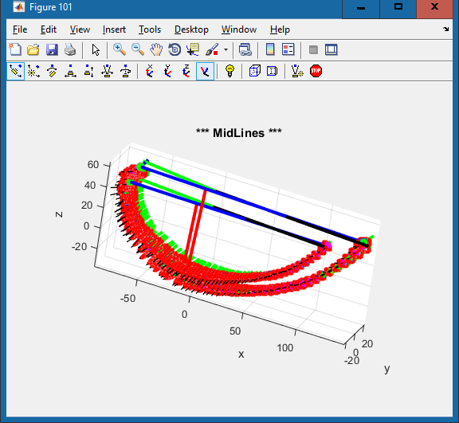 | 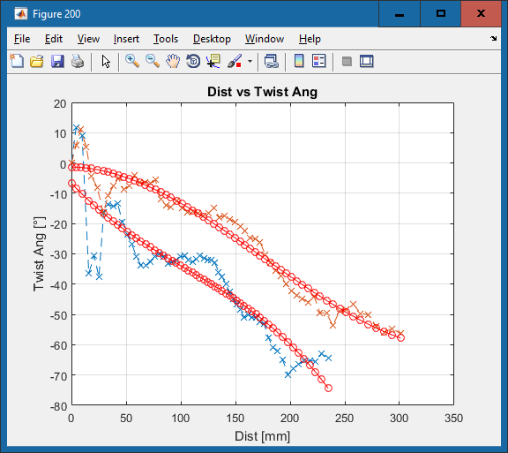
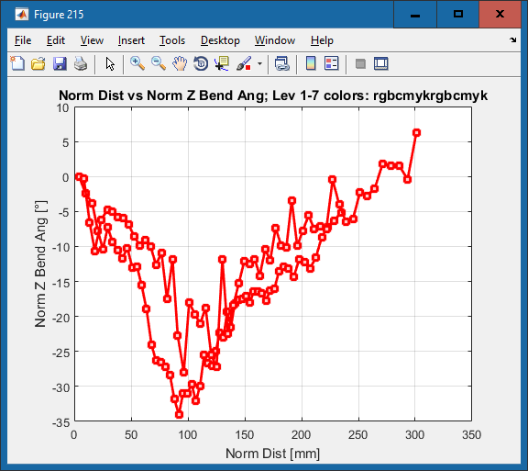 | 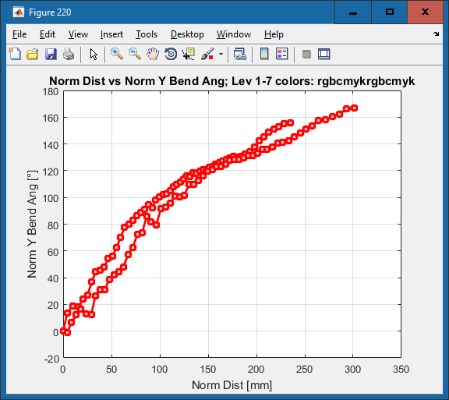
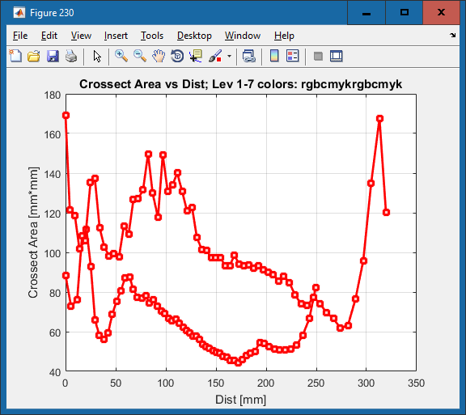 | 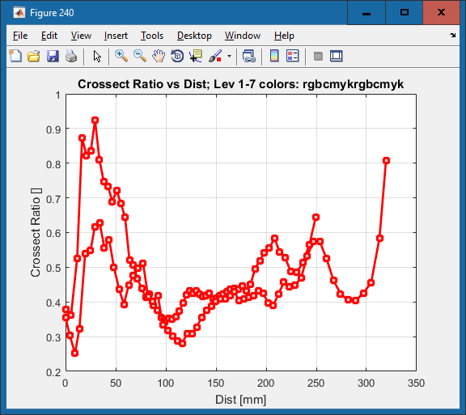

3) User interface and user actions required to inject INPUT data into the algorithms
- User palpates 3 landmarks on the object.
- From these 3 landmarks – a reference frame should be created and a bounding box should be created. This can be in Operations – Create – Derive – Bounding box
- Once the bounding box has been created A function to automatically define the centre line of an object similar to the function of MIMICS detailed in Sookyoung et al. (2017) and also (https://www.youtube.com/watch?v=_JLrp18fAtQ). This can be in Operations – Create – Derive
- A function should also be created which will enable the user to specify the distance between points which calculate the centre line (i.e. 1mm or 3mm). The standard could be 1mm. The points should automatically become landmarks with names on the object (i.e.) underneath a bone you have centre line and then you have a list of ALs which is the centre line.
- A second function should be created which will enable the user to specify from which point in the centre line to take the measurements from (i.e. in the femur, only the diaphysis is relevant). What are the possibilities here? Is it possible to move a plane on the bounding box or better still it would be better to define what points to use from the centreline. If each AL on the centre line was named then you should be able to specify that you want the line to start at landmark x and finish at landmark y.

Chapman, T., Beyer, B., Sholukha, V., Semal, P., Feipel, V., Louryan, S., Van Sint Jan, S., 2017. How different are the Kebara 2 ribs to modern humans? J Anthropol Sci.

