**STRUCTURE CHART:**

**Alex Davey**

**Research Assistant**

**(maternity leave)**

**Jennifer Martin**

**PA to the Regius Keeper**

**Simon Milne MBE**

**Regius Keeper**

**Alasdair Macnab**

**Director of Corporate Services**

**Heather Jackson Director of Enterprise**

**David Rae**

**Director of Horticulture**

**Pete Hollingsworth Director of Science**

**SCIENCE MANAGEMENT**

**Pete Hollingsworth**

**Director of Science**

Conservation Biology

Systematics

Molecular Ecology

China Programme



**David Harris**

**Deputy Director of Science**

**Head of Herbarium**



**Rachael Brewer**

**PA to the Director of Science**

**Lorna Mitchell**

**Head of Library**

**Hamish Adamson**

**Head of**

**Publications**



**Michelle**

**Hollingsworth**

**Head of STS**



**Antje Ahrends**

**Head of Genetics & Conservation**

**Chris Ellis**

**Head of Cryptogams**

**Toby Pennington**

**Head of Tropical**

**Mark Watson**

**Head of Major Floras**

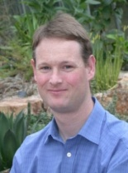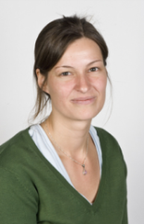

**Tony Miller**

**Head of Centre for Middle Eastern Plants (CMEP)**



**FACILITIES**

**RESEARCH SECTIONS**

**CONSULTANCY/RESEARCH**

